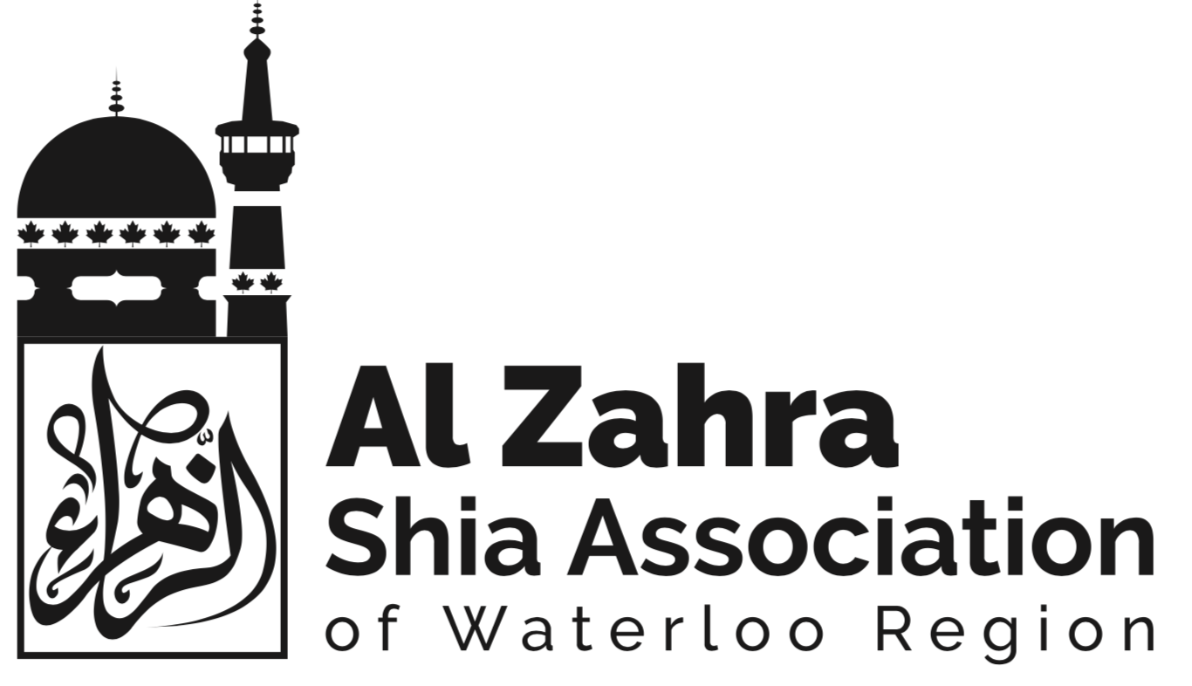

Burial Committee

Objective
To facilitate burial services for members of the Al Zahra Shia Association of Waterloo Region (“Al Zahra”).

Responsibility and Authority
The committee will be responsible for the following:
- Receive notifications from the community regarding a death from among the Members of Al Zahra, as well as from among the larger body of Shia Muslims in the Kitchener-Waterloo region.
- Contact local Funeral Homes to arrange for transport of the deceased
- Perform ritual ablutions (“Ghusl”) and burial shrouding (“Kafan”) on the deceased, in accordance with Shia Muslim rites.
- Prepare a casket (where feasible and requested) for the deceased
- Coordinate with the Program Organizing Committee to plan a ritual mourning ceremony (“Majlis-e-Aza”) in memorium for the deceased.
- report as necessary to the Board of Directors, and advise the Board of major issues related to its mandate
- regularly review its Terms of Reference and make recommendations for changes

Membership
Chair:
- TBD - must be member of Al Zahra, and experienced in all matters pertaining to burial rites according to the Shia Muslim faith.
- 2 additional members of Al Zahra

Term:
- three years, renewable for additional terms upon approval by the Board

Meeting Frequency and Manner
- Determined by the Chair of the committee and President of Al-Zahra
- This committee will continue to meet throughout the active operations of Al-Zahra

Manner of call:
- In-person meetings
- Conference calls
- Text Messaging Platforms

Accountability
- The Building Committee is accountable to, and will report to the Board, providing copies of its plans annually for approval and its minutes, reports and other documents upon request.

