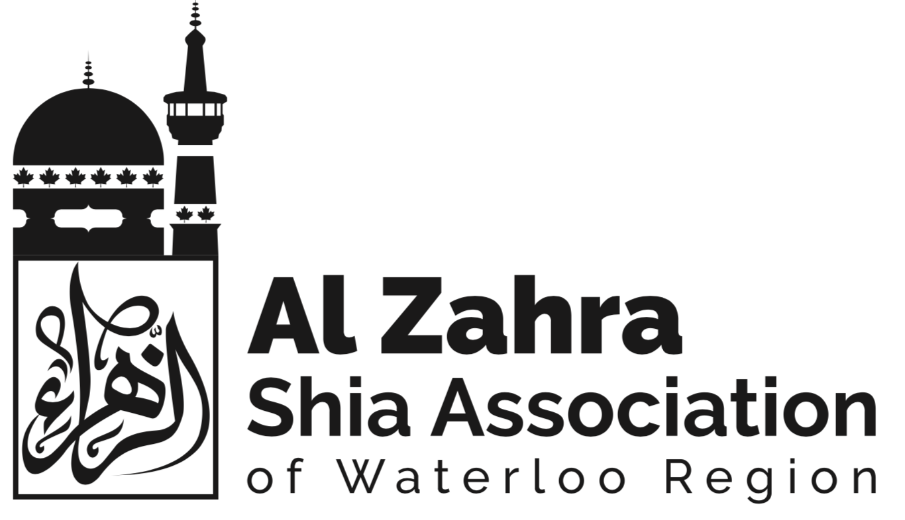
CODE OF CONDUCT

Objective
To Provide a set of rules outlining the norms, rules, and responsibilities of, and or proper practices for the directors of the Al-Zahra Shia Association of Waterloo Region.
To provide a set of principles to guide the behaviour of the directors of the Al-Zahra Shia Association of Waterloo Region

Code of Conduct
All directors of Al-Zahra Shia Association of Waterloo Region must always act with appropriate Islamic behaviour and the laws which govern the Province of Ontario and Government of Canada.

FAIRNESS AND JUSTICE

- As directors of Al Zahra Shia Association of Waterloo Region, we are ethically responsible for promoting and fostering fairness and justice for all members and directors of the association.

- To create and sustain an environment that encourages all individuals and the organization to reach their fullest potential in a positive and productive manner.

Guidelines
1. Respect the uniqueness and intrinsic worth of every individual.
2. Treat people with dignity, respect and compassion to foster a trusting work
environment free of harassment, intimidation, and unlawful discrimination.
3. Ensure that everyone has the opportunity to develop their skills and new competencies.
4. Assure an environment of inclusiveness within the organization.
5. Develop, administer and advocate policies and procedures that foster fair, consistent and equitable treatment for all inline with the laws governing the Province of Ontario and Government of Canada.
6. Regardless of personal interests, support decisions made by our organizations that are both ethical and legal.

CONFLICTS OF INTEREST

- As directors of Al-Zahra Shia Association of Waterloo Region, we must maintain a high level of trust with our stakeholders. We must protect the interests of our stakeholders as well as our professional integrity and should not engage in activities that create actual, apparent, or potential conflicts of interest.

- To avoid activities that are in conflict or may appear to be in conflict with any of the provisions of this Code of Ethical and Professional Standards or with one's responsibilities and duties as a member of the not-for-profit consulting profession and/or as an employee of any organization.

Guidelines
1. Refrain from using your position for personal, material or financial gain or the appearance of such.
2. Refrain from giving or seeking preferential treatment in the human resources processes.
3. Prioritize your obligations to identify conflicts of interest or the appearance thereof; when conflicts arise, disclose them to relevant stakeholders.

USE OF INFORMATION

- As directors of Al-Zahra Shia Association of Waterloo Region, consider and protect the rights of individuals, especially in the acquisition and dissemination of information while ensuring truthful communications and facilitating informed decision-making.

- To build trust among all organization constituents by maximizing the open exchange of information, while eliminating anxieties about inappropriate and/or inaccurate acquisition and sharing of information

Guidelines
1. Acquire and disseminate information through ethical and responsible means.
2. Ensure only appropriate information is used in decisions affecting the employment
relationship.
3. Investigate the accuracy and source of information before allowing it to be used in
employment related decisions.
4. Maintain current and accurate HR information.
5. Safeguard restricted or confidential information.

